Cognizant / Unified Rewards Platform
Low Level Design (LLD) Document

Version: 1.0
Date: 23/05/2026
Classification: C3 – Private

 | Prepared By / Last Updated By | Reviewed By | Approved By
Name | Sandhya
Role | Tech Lead
Signature
Date | 23/05/2026

Table of Contents
Table of Contents 3
1.0 TRADEMARKS, DEFINITIONS AND ACRONYMS 4
1.1 TRADEMARKS 4
1.2 ABBREVIATIONS, TERMS AND DEFINITIONS 4
2.0 DOCUMENT PURPOSE AND EXECUTIVE SUMMARY 5
2.1 DESIGN OBJECTIVES AND SCOPE 5
2.2 IN SCOPE 5
2.3 OUT OF SCOPE AND EXCLUSIONS 6
3.0 REQUIREMENTS 7
3.1 FUNCTIONAL REQUIREMENTS 7
3.2 NON-FUNCTIONAL REQUIREMENTS 8
3.3 ARCHITECTURAL DESIGN DECISIONS 8
4.0 DETAILED DESIGN 10
4.1 SOLUTION ARCHITECTURE 10
4.2 DETAILED DESIGN – LOGICAL 10
4.3 LOGICAL ARCHITECTURE 11
4.4 DESIGN COMPONENTS 11
4.5 SERVER ROLES 12
4.6 SERVER SIZING DETAILS 13
4.7 APPLIANCE DETAILS (ADJUST AS APPLICABLE FOR APPLIANCES) 14
4.8 SOFTWARE PRE-REQUISITES 14
4.9 EXTERNAL REFERENCES 15
4.10 COMPONENT AND CONFIGURATION DETAILS 16
5.0 ADDITIONAL DESIGN COMPONENTS 17
5.1 HIGH AVAILABILITY (OPTIONAL) 17
5.2 DISASTER RECOVERY (OPTIONAL) 17
5.2.1 DR Strategy 17
5.2.2 RTO AND RPO TARGETS 18
5.2.3 DR FAILOVER TESTING 18
5.2.4 BACKUP AND RECOVERY PROCEDURES 19
5.3 NAMESPACE AND NUMBERING SCHEMES 19
6.0 DETAILED DESIGN – PHYSICAL 21
6.1 RACK ELEVATION DIAGRAM 21
6.2 COMPONENT PHYSICAL DETAILS 21
7.0 DETAILED DESIGN – SYSTEM INTEGRATION MODEL 23
7.1 SYSTEM INTEGRATION DETAILS 23
7.1.1 DATABASE 23
7.1.2 BACKUP REQUIREMENTS 23
7.1.3 ANTI-VIRUS 24
7.1.4 MONITORING 25
7.1.5 LOGGING 26
7.1.6 SOURCE AND DESTINATION PORTS 26
7.1.7 SERVICE ACCOUNTS 27
7.1.8 SYSTEM ADMINISTRATION 29
7.1.9 CAPACITY AND SCALABILITY MANAGEMENT 29
8.0 DOCUMENTS REFERENCED 31
9.0 LIST OF TABLES 32
10.0 LIST OF FIGURES 33
11.0 CHANGE LOG 33

1.0 TRADEMARKS, DEFINITIONS AND ACRONYMS
Disclaimer: Systems or products mentioned in this document may not bear the trademarks of their Vendors or Owners. Herein, it is acknowledged that all the trademarks are the property of their respective owners. It is also acknowledged that there is no intention of breaching anybody's copyrights, if there are extractions from any vendors' documents.

1.1 TRADEMARKS
Brand of Product | Description | Company
Microsoft Azure | Cloud computing platform and infrastructure | Microsoft Corporation
ASP.NET Core 8 | Open-source web framework for .NET | Microsoft Corporation
React | JavaScript UI library for building MFE portals | Meta Platforms Inc.
Webpack 5 | JavaScript module bundler with Module Federation | OpenJS Foundation
Entity Framework Core | Object-Relational Mapper for .NET | Microsoft Corporation
Tesseract.Net | OCR library for .NET applications | Iron Software
Serilog | Structured logging framework for .NET | Serilog Contributors
MediatR | CQRS / Mediator library for .NET | Jimmy Bogard
NRules | Rules engine for .NET | NRules Project
FluentValidation | Validation library for .NET | Jeremy Skinner
ClosedXML | Library for reading/writing Excel XLSX files | ClosedXML Contributors
Polly | Resilience and transient-fault-handling library | App-vNext / Microsoft
Docker | Container platform | Docker Inc.
GitHub Actions | CI/CD automation platform | GitHub Inc.

1.2 ABBREVIATIONS, TERMS AND DEFINITIONS
Abbreviation | Definition | Abbreviation | Definition
AKS | Azure Kubernetes Service | APIM | Azure API Management
CQRS | Command Query Responsibility Segregation | MFE | Micro Frontend
HPA | Horizontal Pod Autoscaler | DLQ | Dead Letter Queue
JWT | JSON Web Token | RBAC | Role-Based Access Control
MSI | Managed Service Identity | TDE | Transparent Data Encryption
GRS | Geo-Redundant Storage | PITR | Point-in-Time Restore
OCR | Optical Character Recognition | CTC | Cost to Company
WAF | Web Application Firewall | CDN | Content Delivery Network
MFA | Multi-Factor Authentication | SLA | Service Level Agreement
AMQP | Advanced Message Queuing Protocol | TTL | Time To Live
VNet | Azure Virtual Network | NSG | Network Security Group
HLD | High Level Design | LLD | Low Level Design
RTO | Recovery Time Objective | RPO | Recovery Point Objective
PF | Provident Fund | HRA | House Rent Allowance
LTA | Leave Travel Allowance | DR | Disaster Recovery

2.0 DOCUMENT PURPOSE AND EXECUTIVE SUMMARY

2.1 DESIGN OBJECTIVES AND SCOPE
The objective of this document is to provide low-level technical details of the solution for Cognizant / Unified Rewards Platform (URP). This Low Level Design (LLD) document, as well as all deliverables produced as part of this project, are considered a living document. Revisions are expected and shall be made during the review process with Cognizant stakeholders, as well as in subsequent phases if it is discovered that a process or design can be enhanced to benefit the overall outcome of the project.
This document provides granular technical specifications for: component configurations, service-level design decisions, database schemas, port matrices, service accounts, monitoring thresholds, HA/DR strategies, and capacity planning for the Unified Rewards Platform deployed on Microsoft Azure.

2.2 IN SCOPE
The following technical solutions are considered to be in scope for this LLD:
- 7 ASP.NET Core 8 Microservices: Employee, Benefits, Compensation, Claims, Documents, Payroll, Reporting — component-level design, MediatR handler structure, EF Core configuration, caching strategy, and event publishing.
- 4 React 18 Micro Frontend Portals: Shell Host + Employee, Manager, HR Admin, Finance Remotes — Webpack 5 Module Federation configuration, JWT Context, Axios interceptor, and role-based routing.
- Azure Kubernetes Service (AKS): Cluster configuration, node pool sizing, HPA settings, namespace structure, pod resource limits, network policies, and rolling deployment strategy.
- Azure API Management (APIM): API policy definitions, rate limiting configuration, JWT validation policy, CORS settings, and backend service routing rules.
- Data Layer: Azure SQL schema design (table structure, indexes, constraints), Azure Cosmos DB container configuration (partition keys, throughput), Azure Redis Cache key design and TTL strategy.
- Azure Service Bus: Topic and subscription configuration, message schema, Dead Letter Queue handling.
- Azure Event Hub: Partition configuration, consumer group design, retention settings, Serilog sink setup.
- Azure Functions: Blob Trigger (OCR), Timer Trigger (scheduled reports), Queue Trigger (payroll batch) — function app configuration and bindings.
- Security: Azure Key Vault secret naming conventions, Managed Identity assignments per service, network security group (NSG) rules, private endpoint configuration.
- CI/CD: GitHub Actions workflow structure per service, container image build and push to ACR, AKS deployment strategy.
- Monitoring: Azure Monitor alert rules, Application Insights custom metrics, log query definitions.
- HA / DR: AKS multi-zone deployment, Azure SQL auto-failover group, Cosmos DB multi-region write, RTO/RPO targets, and failover procedures.

2.3 OUT OF SCOPE AND EXCLUSIONS
The following technical solutions are considered to be out of scope for this LLD:
- Internal configuration, administration, or schema design of external payroll systems (SAP / ADP / Workday).
- Mobile native application development — not in scope for Release 1.0.
- Legacy HR system data migration — covered in a separate Migration Design document.
- Azure Active Directory tenant configuration and Conditional Access Policy administration — managed by the Cognizant IT Security team.
- Network infrastructure outside the Azure VNet (corporate WAN, on-premise network).
- Third-party SLA definitions beyond the Microsoft Azure SLA framework.

3.0 REQUIREMENTS
The needs of Cognizant stakeholders are the basis for determining requirements. The stakeholder needs, expectations, constraints, interfaces, operational concepts, and product concepts are analyzed, harmonized, refined, and elaborated for translation into a set of customer requirements. The following are the business and functional requirements established for the Unified Rewards Platform.

3.1 FUNCTIONAL REQUIREMENTS
Table below lists the Functional Business and Technical Requirements:
FR ID | Requirement | Pertinent Design Component
FR-01 | Employee Benefits Management — Employee shall be able to view and enroll in eligible benefit plans (Health Insurance, LTA, Meal Card, Flexi). Eligibility evaluated by grade, tenure, employment type, and location. | Benefits Service (ASP.NET Core 8), Azure Cosmos DB (BenefitPlans container), EligibilityCriteria Evaluator, Employee Remote MFE
FR-02 | Expense Claim Submission — Employee shall submit expense claims with line items and OCR-scanned receipts. Claim status transitions: DRAFT → SUBMITTED → UNDER_REVIEW. | Claims & Documents Service (state machine), Document & OCR component (Tesseract.Net), Azure Blob Storage (receipts), Azure Service Bus (ClaimSubmittedEvent)
FR-03 | Manager Claim Approval — Manager shall review and approve or reject claims for own team within 7-business-day SLA. Rejection requires mandatory reason. | Claims & Documents Service (ClaimWorkflow), Manager Remote MFE, Azure Service Bus (ClaimApproved/RejectedEvent), Email Service
FR-04 | OCR Receipt Processing — System shall extract vendorName, receiptDate, and receiptAmount from uploaded receipt images with confidence scoring. | Document & OCR component, Azure Function (Blob Trigger), Tesseract.Net, OCRResult entity (Azure SQL)
FR-05 | Compensation Management — HR Admin shall configure grade-based compensation rules using NRules Engine. Rules compute BasicPay, HRA, Bonus, and PF per employee. | Compensation Service, NRules Engine, Azure Cosmos DB (CompensationRules container), HR Admin Remote MFE
FR-06 | Payroll Settlement — Approved claims shall settle in the next payroll cycle. Finalized payroll pushed to external SAP/ADP/Workday system with Polly 3× retry. | Payroll Service, Settlement handler, ClosedXML (PaySlip), IPayrollService adapter, Polly retry policy
FR-07 | Promotion Cycle Management — HR Admin shall create promotion cycles with eligibility criteria. Managers nominate team members. Outcomes recorded by HR Admin. | Promotions Service, PromotionEligibility evaluator, PromotionNomination entity, HR Admin Remote MFE
FR-08 | Compliance Reporting — Finance User shall generate Claim Summary, Compensation, and Audit reports with export to XLSX / PDF. | Reporting Service, ClosedXML, Azure Blob Storage (reports), Azure SQL (Reports, AuditEntries), Finance Remote MFE
FR-09 | Real-time Audit Trail — All platform actions shall be captured as immutable AuditEntry records via Azure Event Hub. | Azure Event Hub, Serilog Event Hub sink, Reporting Service (AuditEntry ingestion), Azure SQL (AuditEntries)
FR-10 | Role-Based Access Control — Four roles (EMPLOYEE, MANAGER, HR_ADMIN, FINANCE_USER) shall enforce access control at API and UI levels. | Azure AD JWT (RS256), APIM JWT validation policy, [Authorize] ASP.NET Core middleware, React Role Guards
FR-11 | Multi-Region Availability — Platform shall maintain 99.9%+ availability with auto-failover for critical data services. | AKS HPA, Azure SQL auto-failover group, Cosmos DB multi-region write, Azure Redis Zone-redundant
FR-12 | Benefit Deduction Integration — Approved benefit enrollments shall automatically register premium deductions with Payroll Service. | Benefits Service → Payroll Service (internal REST call), PayrollDeduction entity, Azure SQL
FR-13 | PaySlip Generation and Download — Employee shall download monthly PaySlip PDF post-payroll finalization. | Payroll Service, ClosedXML PDF generation, Azure Blob Storage (payslips/), Employee Remote MFE

Use Case Diagrams

System Use Case Overview
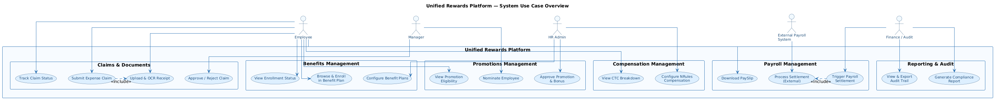
Figure: Unified Rewards Platform — System Use Case Overview (All Actors & 7 Modules)

UC-01: User Management
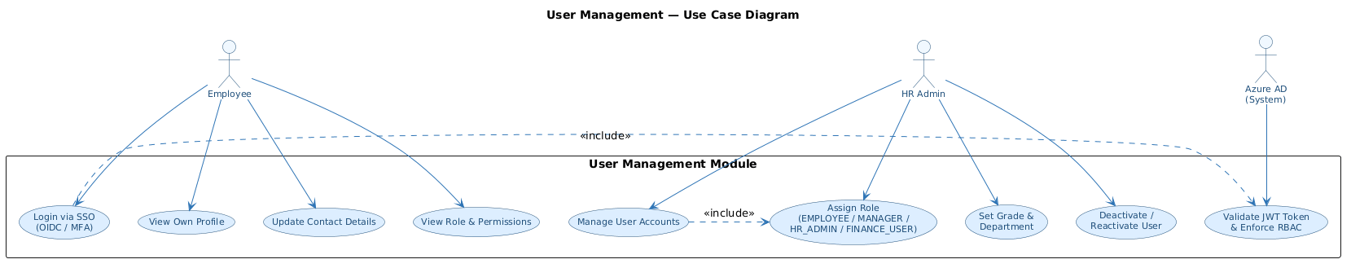
Figure: UC-01: User Management — Use Case Diagram

UC-02: Benefits Management
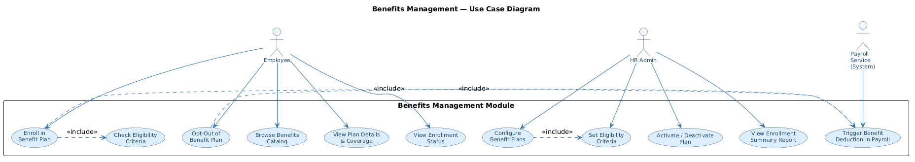
Figure: UC-02: Benefits Management — Use Case Diagram

UC-03: Compensation Management
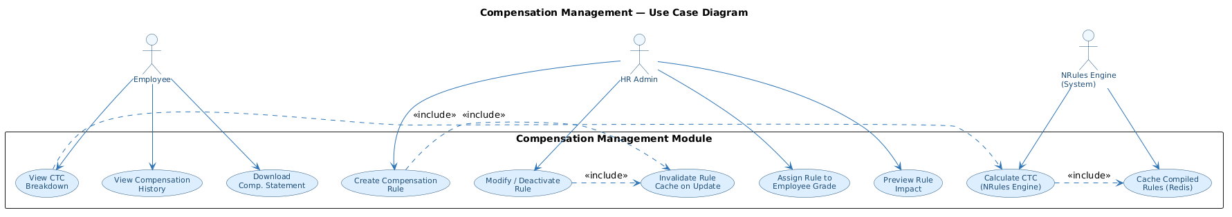
Figure: UC-03: Compensation Management — Use Case Diagram

UC-04: Claims & Documents Management
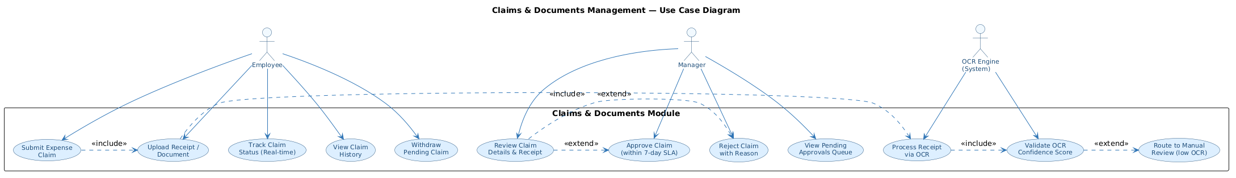
Figure: UC-04: Claims & Documents Management — Use Case Diagram

UC-05: Payroll Management
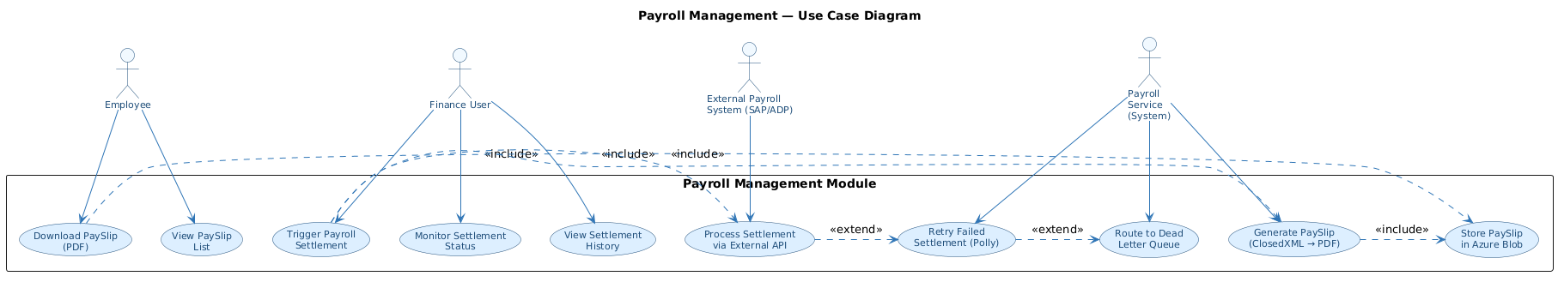
Figure: UC-05: Payroll Management — Use Case Diagram

UC-06: Promotions Management
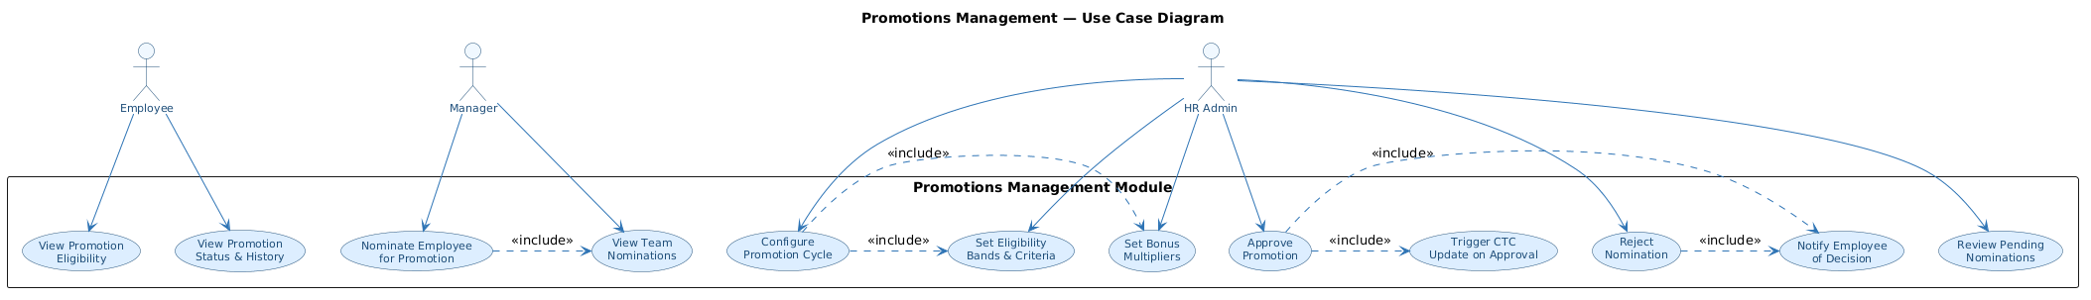
Figure: UC-06: Promotions Management — Use Case Diagram

UC-07: Reporting & Audit
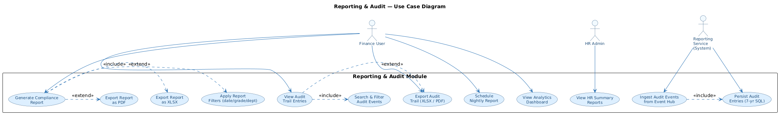
Figure: UC-07: Reporting & Audit — Use Case Diagram

3.2 NON-FUNCTIONAL REQUIREMENTS
Table below lists the Non-Functional Business Requirements:
NFR ID | Requirement | Pertinent Design Component
NFR-01 | High Availability — System components shall be designed for zero single-point-of-failure. Minimum 2 pods per AKS service; zone-redundant data services. | AKS HPA (min 2, max 10 pods); Azure SQL Zone-redundant; Cosmos DB multi-region; Redis Premium Zone-redundant
NFR-02 | Performance — API response time < 500ms (P95) for synchronous endpoints; < 2s for report generation initiation. | Azure Redis Cache (TTL: 15/30/60 min); APIM caching policy; EF Core async queries; Cosmos DB auto-scale RU
NFR-03 | Scalability — Platform shall scale horizontally to support 10,000 concurrent employees without architectural changes. | AKS HPA (CPU/memory-based); Cosmos DB auto-scale (400–4000 RU/s); Azure SQL elastic pool; Service Bus Premium
NFR-04 | Security — All data at rest encrypted (AES-256); all data in transit encrypted (TLS 1.3); zero stored credentials. | Azure SQL TDE; Cosmos DB server-side encryption; Blob SSE; Key Vault MSI; Private VNet endpoints
NFR-05 | Disaster Recovery — RTO: 30 minutes; RPO: 5 minutes for transactional data; RPO: 1 hour for document storage. | Azure SQL auto-failover group; Cosmos DB multi-region write; Blob GRS; AKS DR cluster (West US 2)
NFR-06 | Audit and Compliance — Immutable audit trail for all domain actions; 30-day Event Hub retention; 7-year SQL audit record retention. | Azure Event Hub (append-only); AuditEntries (Azure SQL, immutable); ClaimStatusHistory (append-only)
NFR-07 | Maintainability — Independent deployment per service/portal; zero-downtime rolling deployments; < 15-minute deployment time per service. | GitHub Actions per-service pipeline; AKS rolling update strategy (maxSurge:1, maxUnavailable:0); Docker multi-stage build
NFR-08 | Observability — Distributed tracing across all services; custom metric dashboards; PagerDuty integration for critical alerts. | Azure Application Insights (x-correlation-id propagation); Azure Monitor alert rules; Serilog structured logging

3.3 ARCHITECTURAL DESIGN DECISIONS
This section documents the key decisions made while preparing the design from the architecture perspective:
Decision ID | Design Decision | Description | Rationale & Justification
AD-01 | Microservices Architecture (7 services) | Platform decomposed into 7 independently deployable ASP.NET Core 7 microservices, each owning its data domain. | Domain isolation enables independent scaling, deployment, and fault isolation. Prevents cascading failures across domains.
AD-02 | MediatR CQRS Pattern | All business logic implemented as MediatR Commands and Queries. Zero business logic in Controllers. | Strict separation of concerns; Commands (writes) and Queries (reads) are independently testable and auditable.
AD-03 | Module Federation for Micro Frontends | Webpack 5 ModuleFederationPlugin used to lazy-load 4 role-specific Remote Apps from a Shell Host at runtime. | Independent frontend deployment without Shell App changes. Each portal has its own CI/CD pipeline and versioning.
AD-04 | NRules Engine for Compensation | Compensation rules stored as NRules formulas in Cosmos DB; evaluated at runtime without redeployment. | HR Admin can update grade-based CTC rules without developer involvement or code deployment.
AD-05 | Event-Driven Claim Settlement (Service Bus) | Claims & Documents Service publishes ClaimApproved event to Azure Service Bus; Payroll Service subscribes to trigger Settlement. | Full decoupling of Claims and Payroll domains. Payroll Service can fail/restart without impacting claim processing.
AD-06 | Polyglot Persistence (SQL + Cosmos DB) | Azure SQL for transactional domains (Claims, Payroll, Employees); Cosmos DB for flexible-schema domains (Benefits, Compensation). | SQL for ACID-compliant transactional data; Cosmos DB for high-read, variable-schema document data. Right tool per domain.
AD-07 | JWT in React Context (not localStorage) | JWT Bearer token stored in React Context (in-memory heap). Never stored in localStorage or sessionStorage. | Prevents XSS-based token theft. Token lost on page refresh forces re-authentication via Azure AD — intentional security design.
AD-08 | Managed Identity (Zero-credential architecture) | All Azure service connections use MSI (Managed Identity). No stored passwords or API keys in configuration. | Eliminates credential exposure risk in config files, Kubernetes secrets, or CI/CD pipelines. Key rotation without downtime.
AD-09 | Private VNet for all Data Services | Azure SQL, Cosmos DB, Redis, Blob, Key Vault, Service Bus, Event Hub accessible only via Private Link within VNet. | No public internet exposure of data tier. Defence-in-depth: even if APIM is compromised, data tier is unreachable.
AD-10 | Polly Resilience for External Payroll | IPayrollService uses HttpClientFactory + Polly retry (3×, exponential back-off) + circuit breaker + Dead Letter Queue. | External payroll systems (SAP/ADP/Workday) may have transient failures. Polly prevents cascading failure; DLQ enables manual recovery.

4.0 DETAILED DESIGN
This section provides the low-level technical design for the Unified Rewards Platform. It covers solution architecture, logical design, component configuration, server roles, sizing, software prerequisites, and detailed component specifications for each layer of the platform.

4.1 SOLUTION ARCHITECTURE
The Unified Rewards Platform is a cloud-native, microservices-based HR Technology platform deployed exclusively on Microsoft Azure. The architecture follows a 5-tier model:
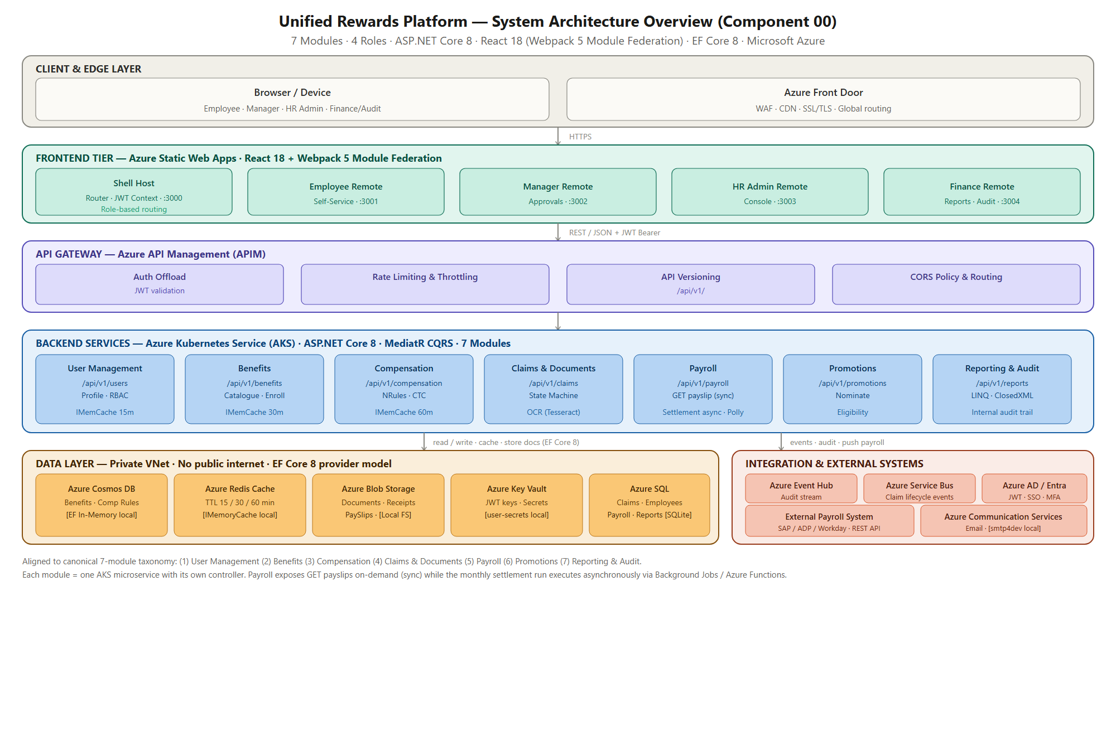
Figure: Solution Architecture Overview — 5-Layer System Context

All user interactions originate from web browsers. Requests traverse Azure Front Door (WAF inspection, CDN caching for static assets) before reaching the React MFE portals served from Azure Static Web Apps. API calls from portals flow through Azure APIM, which enforces JWT validation and rate limiting before routing to the target AKS microservice. Services communicate with data stores exclusively via Private Link within the Azure VNet — no data service has a public endpoint. Asynchronous domain events (claim lifecycle) flow through Azure Service Bus. All audit events stream to Azure Event Hub for compliance ingestion by the Reporting Service.

4.2 DETAILED DESIGN – LOGICAL
The logical design describes the internal structure of each microservice and the interactions between them. Each of the 7 microservices follows the same 4-layer internal structure:
- Controller Layer: Minimal ASP.NET Core 8 controllers. Only responsibility is receiving HTTP requests and dispatching via ISender.Send(command/query). No business logic.
- Application Layer (MediatR): IRequestHandler<Command,Result> for writes; IRequestHandler<Query,Result> for reads. FluentValidation Pipeline Behavior validates before handler execution. INotificationHandler for domain event processing.
- Domain Layer: Entity classes, Value Objects, Domain Events, and Business Rules. No infrastructure dependencies.
- Infrastructure Layer: EF Core 8 DbContext (Repository pattern), external service adapters (IPayrollService, IEmailService, IOCRService, IStorageService, IAuditEventEmitter), and Azure SDK clients.
Layer | Technology | Key Components
Controller | ASP.NET Core 8 minimal controllers | [ApiController], [Authorize(Roles="...")], ISender.Send()
Application (CQRS) | MediatR v12.x + FluentValidation v11.x | Command/QueryHandlers, ValidationBehavior, IPublisher
Domain | C# domain models, enums, value objects | Entities (Claim, Employee, etc.), ClaimStatus enum, ClaimWorkflow state machine
Infrastructure (DB) | EF Core 8 + Azure SQL / Cosmos SDK | DbContext, Repository<T>, IUnitOfWork, Migrations
Infrastructure (Cache) | StackExchange.Redis / IMemoryCache | ICacheService wrapper, TTL-keyed cache entries
Infrastructure (Messaging) | Azure Service Bus SDK + Event Hub SDK | IMessagePublisher, IEventHubEmitter, MSI credentials
Infrastructure (Adapters) | HttpClientFactory + Polly | IPayrollService, IEmailService, IOCRService (local mock + cloud impl)

4.3 LOGICAL ARCHITECTURE
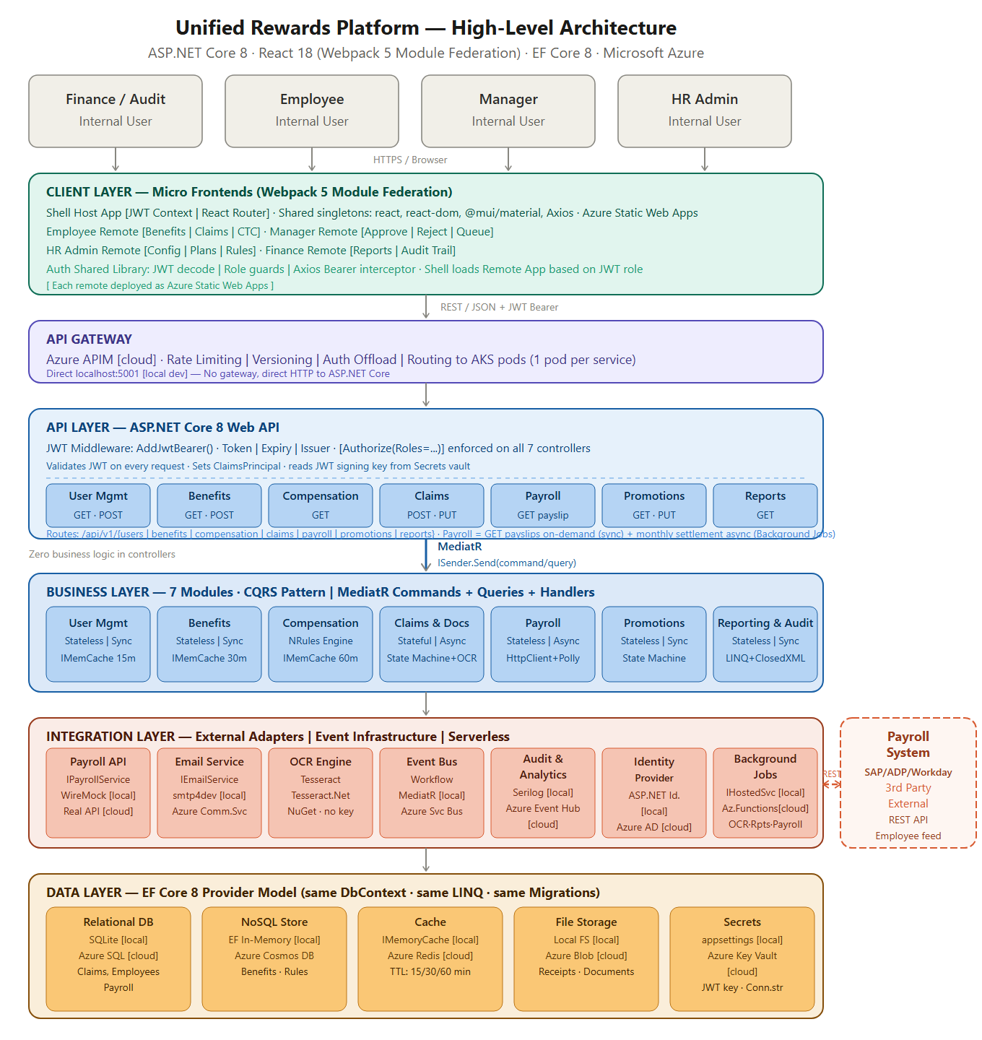
Figure: Logical Architecture Diagram — Horizontal Tiers & Cross-cutting Concerns

4.4 DESIGN COMPONENTS
The following design components are identified for the Unified Rewards Platform. Each component is independently configurable and deployed:
Component | Type | Technology | Configuration Highlight
User Management Service | Microservice | ASP.NET Core 8 + EF Core 8 | SQL: Employees+Users tables; Cache TTL: 15 min; IMemoryCache key: employee:{id}
Benefits Service | Microservice | ASP.NET Core 8 + Cosmos SDK | Cosmos container: BenefitPlans; Cache TTL: 30 min; EligibilityCriteria evaluator
Compensation Service | Microservice | ASP.NET Core 8 + NRules + Cosmos | Cosmos container: CompensationRules; NRules compiled at startup; Cache TTL: 60 min
Claims & Documents Service | Microservice | ASP.NET Core 8 + EF Core 8 | SQL: Claims+Workflow+History; State machine; publishes 4 Service Bus topics
Document & OCR component | Microservice | ASP.NET Core 8 + Azure Blob | Blob container: documents/; OCR via Azure Function Blob Trigger; Tesseract.Net
Payroll Service | Microservice | ASP.NET Core 8 + EF Core 8 + Polly | SQL: PayrollRecords+Settlements; ClosedXML PaySlip; Polly 3× retry; DLQ
Reporting Service | Microservice | ASP.NET Core 8 + EF Core 8 + ClosedXML | SQL: Reports+AuditEntries; LINQ aggregation; XLSX/PDF export; internal only
Shell Host App | MFE (React) | React 18 + Webpack 5 MFP | Host config: remoteEntry.js per remote; JWT Context; React Router v6
Employee Remote | MFE (React) | React 18 + MUI v5 | Routes: /benefits, /claims, /ctc, /payslips; Axios Bearer interceptor
Manager Remote | MFE (React) | React 18 + MUI v5 | Routes: /approvals, /nominations; MANAGER role guard
HR Admin Remote | MFE (React) | React 18 + MUI v5 | Routes: /plans, /rules, /promotions; HR_ADMIN role guard
Finance Remote | MFE (React) | React 18 + MUI v5 | Routes: /reports, /audit; FINANCE_USER role guard; ClosedXML export trigger
Azure APIM | Gateway | Azure API Management | 100 req/min rate limit; JWT RS256 validation; CORS; /api/v1/ routing; Private Link → AKS
Azure AKS | Orchestration | Kubernetes v1.28+ | 2 node pools: system (Standard_D2s_v3) + user (Standard_D4s_v3); HPA 2–10 pods
Azure SQL Database | Data Store | SQL Server 2022 compat | General Purpose GP_Gen5_4; Zone-redundant; Geo-replica West US 2; PITR 35 days
Azure Cosmos DB | Data Store | Core (SQL) API | 400–4000 RU/s auto-scale; 2 regions (EUS2+WUS2); BenefitPlans+CompensationRules containers
Azure Redis Cache | Cache | Premium P1 (6 GB) | Zone-redundant; TLS 6380; no persistence (AOF/RDB disabled); eviction: allkeys-lru
Azure Blob Storage | Storage | StorageV2 GRS | Containers: documents/, payslips/, reports/; Soft delete: 14 days; Private endpoint
Azure Service Bus | Messaging | Premium tier | 4 topics: claims/submitted, claims/approved, claims/rejected, claims/settled; TTL: 7 days
Azure Event Hub | Audit Stream | Standard tier | 1 Event Hub: audit-events; 32 partitions; 30-day retention; 1 consumer group per service
Azure Functions | Serverless | v4 (.NET 8 isolated) | 3 triggers: BlobTrigger (OCR), TimerTrigger (reports 0 6 * * *), QueueTrigger (payroll batch)
Azure Key Vault | Secrets | HSM Standard | Secrets: jwt-signing-key, sql-conn-str, cosmos-conn-str, redis-conn-str, payroll-api-key
Azure Front Door | Edge/CDN | Standard v2 | WAF policy: OWASP 3.2; DDoS Standard; SSL cert: *.unifiedrewards.cognizant.com
Azure AD / Entra ID | Identity | v2.0 OIDC | App registration; PKCE flow; JWT RS256; MFA Conditional Access; 4 app roles assigned

4.5 SERVER ROLES
Datacenter / Location | Server / Service Name | Role | IP Address / Endpoint
Azure East US 2 (Primary) | urp-aks-system-nodepool | AKS System Node Pool (kube-system workloads) | VNet Private: 10.0.1.0/24
Azure East US 2 (Primary) | urp-aks-user-nodepool | AKS User Node Pool (7 microservices + 3 Azure Functions) | VNet Private: 10.0.2.0/24
Azure East US 2 (Primary) | urp-apim.azure-api.net | Azure APIM — API Gateway | Public: apim.unifiedrewards.cognizant.com; Private Link: 10.0.3.4
Azure East US 2 (Primary) | urp-sql-primary.database.windows.net | Azure SQL Database — Primary (Read/Write) | Private Endpoint: 10.0.4.5
Azure West US 2 (DR) | urp-sql-secondary.database.windows.net | Azure SQL Database — Secondary (Read replica, auto-failover) | Private Endpoint: 10.1.4.5
Azure East US 2 + West US 2 | urp-cosmos.documents.azure.com | Azure Cosmos DB — Multi-region write | Private Endpoint EUS2: 10.0.4.6 | WUS2: 10.1.4.6
Azure East US 2 (Primary) | urp-redis.redis.cache.windows.net | Azure Redis Cache Premium P1 | Private Endpoint: 10.0.4.7; TLS Port: 6380
Azure East US 2 (Primary) | urp-blob.blob.core.windows.net | Azure Blob Storage GRS | Private Endpoint: 10.0.4.8
Azure East US 2 (Primary) | urp-keyvault.vault.azure.net | Azure Key Vault | Private Endpoint: 10.0.4.9
Azure East US 2 (Primary) | urp-servicebus.servicebus.windows.net | Azure Service Bus Premium | Private Endpoint: 10.0.4.10; AMQP: 5671
Azure East US 2 (Primary) | urp-eventhub.servicebus.windows.net | Azure Event Hub Standard | Private Endpoint: 10.0.4.11; AMQP: 5671
Azure East US 2 (Primary) | urp-functions.azurewebsites.net | Azure Functions App (OCR + Reports + Payroll batch) | Private Endpoint: 10.0.2.20
Azure East US 2 (Primary) | urp-acr.azurecr.io | Azure Container Registry (stores Docker images) | Private Endpoint: 10.0.3.15
Azure Global | urp-frontdoor.azurefd.net | Azure Front Door (WAF + CDN + SSL) | Public: CNAME → frontdoor.azurefd.net
Azure East US 2 (Primary) | urp-shell.azurestaticapps.net | Static Web App — Shell Host (:3000) | Public CDN; Custom domain: app.unifiedrewards.cognizant.com

4.6 SERVER SIZING DETAILS
Server / Service Name | OS / Runtime | P / V | Cores / vCPU | RAM (GB) | Drive / Storage | Environment
AKS System Node (Standard_D2s_v3) | Ubuntu 22.04 LTS | V (VM) | 2 vCPU | 8 GB | OS: 128 GB SSD (ephemeral) | Prod (×3 nodes, zone-spread)
AKS User Node (Standard_D4s_v3) | Ubuntu 22.04 LTS | V (VM) | 4 vCPU | 16 GB | OS: 128 GB SSD (ephemeral) | Prod (×5 nodes min, HPA-driven)
AKS User Node (Standard_D2s_v3) | Ubuntu 22.04 LTS | V (VM) | 2 vCPU | 8 GB | OS: 128 GB SSD (ephemeral) | UAT (×3 nodes)
Azure SQL — General Purpose | SQL Server 2022 | PaaS (Managed) | 4 vCores (GP_Gen5_4) | 20.4 GB | Data: 256 GB SSD (auto-grow to 4 TB) | Prod (Zone-redundant)
Azure SQL — General Purpose | SQL Server 2022 | PaaS (Managed) | 2 vCores (GP_Gen5_2) | 10.2 GB | Data: 128 GB SSD | UAT
Azure Cosmos DB | PaaS (Serverless) | PaaS (Managed) | N/A (serverless) | N/A | 400–4000 RU/s auto-scale per container | Prod (multi-region)
Azure Redis Cache — P1 | Redis 6.x | PaaS (Managed) | 1 shard | 6 GB RAM | In-memory only (no disk persistence) | Prod (Zone-redundant)
Azure Redis Cache — C1 | Redis 6.x | PaaS (Managed) | 1 shard | 1 GB RAM | In-memory only | UAT
Azure Functions — Consumption | .NET 8 isolated | PaaS (Serverless) | Dynamic | Dynamic | N/A | Prod + UAT
Azure Blob Storage | StorageV2 | PaaS (Managed) | N/A | N/A | GRS; Hot tier; up to 5 PB | Prod

4.7 APPLIANCE DETAILS (ADJUST AS APPLICABLE FOR APPLIANCES)
Appliance / Service Name | Type | SKU / Tier | Capacity | Redundancy | Environment
Azure API Management | PaaS — API Gateway | Developer (UAT) / Premium (Prod) | 500 req/sec (Premium) | Zone-redundant (Premium tier) | Prod + UAT
Azure Front Door | PaaS — Global CDN/WAF | Standard v2 | Unlimited CDN; WAF 100K rules/policy | Global (multi-region by design) | Prod
Azure Service Bus | PaaS — Messaging | Premium tier (Prod) / Standard (UAT) | 10 MB message size; 1 Messaging Unit | Zone-redundant (Premium) | Prod + UAT
Azure Event Hub | PaaS — Event Stream | Standard tier | 32 partitions; 10 MB/s ingest | Zone-redundant | Prod
Azure Key Vault | PaaS — Secret Store | Standard (HSM-backed) | 10,000 ops/10 sec per vault | Zone-redundant | Prod + UAT
Azure Container Registry | PaaS — Image Registry | Standard | 100 GB storage; 10 concurrent builds | Geo-replication (optional) | Prod

4.8 SOFTWARE PRE-REQUISITES
The table below lists all software prerequisites for each component:
Component / Server | Software Component | Version / Notes
AKS Worker Nodes (all) | .NET 8 Runtime | 8.0.x LTS — pre-installed in Docker base image (mcr.microsoft.com/dotnet/aspnet:8.0)
AKS Worker Nodes (all) | Docker / containerd | 26.x / 1.7.x — managed by AKS
AKS Worker Nodes (all) | Azure CNI (networking) | v1.4+ — required for Private VNet integration and NSG enforcement
AKS Worker Nodes (all) | Managed Identity extension | AKS Workload Identity — required for MSI-based access to Key Vault, Blobs, SQL
AKS Worker Nodes (all) | Application Insights Agent | 3.x — auto-instrumentation for distributed tracing (via Helm chart)
Employee/Benefits/Comp Services | Entity Framework Core 8 | 8.x — via NuGet; migrations managed per-service
Compensation Service | NRules Engine | 0.15.x — via NuGet; rules compiled from Cosmos DB formulas at startup
Claims / Payroll Services | MediatR | 12.x — via NuGet; all services use CQRS pipeline
Claims / Payroll Services | FluentValidation | 11.x — via NuGet; pipeline behavior validates all commands/queries
Document & OCR component | Tesseract.Net | 2024.x — via NuGet; requires Tesseract.Net license key (from Key Vault)
Payroll Service | ClosedXML | 0.102.x — via NuGet; PaySlip XLSX/PDF generation
Payroll Service | Polly | 8.x — via NuGet; retry + circuit breaker for external payroll REST calls
All Services | Serilog + Azure EventHub Sink | 3.x + 3.x — structured logging pipeline; cloud sink: EventHub
Azure Functions App | .NET 8 Isolated Worker | 8.0.x — Functions v4 runtime; NuGet: Microsoft.Azure.Functions.Worker
Azure Functions App | Azure.Storage.Blobs SDK | 12.x — Blob Trigger binding for OCR function
MFE Portals (all) | Node.js | 20.x LTS — build-time only; runtime is browser
MFE Portals (all) | React | 18.3.x — via npm
MFE Portals (all) | Webpack 5 + MFP | 5.x + 5.x — ModuleFederationPlugin for host/remote wiring
MFE Portals (all) | Material-UI (@mui/material) | v5.x — shared UI component library (singleton)
MFE Portals (all) | Axios | 1.x — HTTP client with Bearer token interceptor
CI/CD (GitHub Actions) | Docker CLI | 26.x — container image build in pipeline
CI/CD (GitHub Actions) | kubectl | 1.28+ — AKS deployment via kubectl apply
CI/CD (GitHub Actions) | Helm | 3.x — Application Insights agent chart deployment

4.9 EXTERNAL REFERENCES
Document Name | Brief Description | Document Location
Cognizant-UnifiedRewardsPlatform-HLD v1.0 | High Level Design and Architecture Document | docs/HLD_doc/Cognizant-UnifiedRewardsPlatform-HLD v1.0.docx
Cognizant-UnifiedRewardsPlatform-API Specification v1.0 | REST API contracts for all 7 microservices | docs/Cognizant-UnifiedRewardsPlatform-API Specification v1.0.docx
Requirement Analysis & Clarification Document v1.1 | Platform functional and non-functional requirements | docs/Requirement_Analysis_Clarification_Document.md
System Architecture Diagram | C4/component architecture diagram | docs/Diagrams/Architecture_Diagram_1.pdf
Deployment Architecture Diagram | Azure deployment topology with VNet and regions | docs/Diagrams/Deployment_Architecture_Diagram.pdf
ER Diagrams (all domains) | Entity-relationship diagrams for all 7 data domains | docs/Diagrams/ER_Diagrams/ (er_00_master.png through er_07_reporting_audit.png)
Sequence Diagrams (all flows) | End-to-end sequence flows for 6 key business processes | docs/sequences/ (seq_01 through seq_06)
Corporate Security Policy | Cognizant application architecture security standard | https://corporatesecurity.cognizant.com/Policies/QSIS-APPARCDES.pdf
Azure Well-Architected Framework | Microsoft architecture best practices reference | https://learn.microsoft.com/azure/architecture/framework/

4.10 COMPONENT AND CONFIGURATION DETAILS
The component and configuration details comprise the AKS application layer, Azure data services, messaging infrastructure, and security components. Configurations are managed via:
- Kubernetes ConfigMaps: Non-sensitive configuration (service URLs, feature flags, cache TTL values, environment names).
- Azure Key Vault Secrets: All sensitive configuration (connection strings, JWT signing key, external API keys). Fetched at pod startup via Workload Identity MSI.
- Environment Variables (non-sensitive): ASPNETCORE_ENVIRONMENT, AZURE_TENANT_ID, AZURE_CLIENT_ID (Workload Identity).
- Kubernetes Resource Limits per pod: requests: cpu=200m, memory=256Mi; limits: cpu=1000m, memory=512Mi.
- AKS HPA configuration: minReplicas=2, maxReplicas=10, targetCPUUtilizationPercentage=70.
- EF Core migrations: Applied automatically at service startup in non-Production environments; manual migration approval required in Production.

5.0 ADDITIONAL DESIGN COMPONENTS

5.1 HIGH AVAILABILITY (OPTIONAL)
The Unified Rewards Platform is designed for 99.9%+ availability across all tiers. The following HA mechanisms are implemented:
Component | HA Mechanism | Configuration | Failover Time
AKS Microservices | HPA + Multi-zone node pool | minReplicas=2, maxReplicas=10; nodes spread across 3 AZs; RollingUpdate (maxSurge=1, maxUnavailable=0) | < 30 seconds (pod restart)
Azure APIM | Zone-redundant (Premium) | Deployed across 3 Availability Zones in East US 2 | Automatic (no customer action)
Azure SQL Database | Zone-redundant + Auto-failover group | Primary (EUS2) → Secondary (WUS2); auto-failover grace period: 30 min | < 30 seconds (DNS failover)
Azure Cosmos DB | Multi-region write | Write: East US 2 + West US 2; Strong consistency for writes; Eventual for reads | < 5 seconds (automatic regional failover)
Azure Redis Cache | Zone-redundant cluster | Premium P1 with zone-redundancy; no persistence (data reconstructed from DB on restart) | < 60 seconds (replica promotion)
Azure Blob Storage | GRS (Geo-Redundant Storage) | RA-GRS: 6 synchronous copies across 2 paired regions | < 1 hour (Microsoft-initiated for DR)
Azure Service Bus | Zone-redundant (Premium) | Geo-disaster recovery: primary (EUS2) ↔ alias; manual failover | < 15 minutes (manual failover via alias)
Azure Front Door | Global (built-in multi-region) | WAF + CDN across 150+ PoPs globally; automatic health probes | < 60 seconds (backend health probe failover)
Azure Functions | Consumption plan auto-scale | Scales from 0 to 200 instances on demand; no manual HA configuration | Serverless — instantaneous

5.2 DISASTER RECOVERY (OPTIONAL)
The DR strategy for the Unified Rewards Platform is based on Azure paired regions (East US 2 → West US 2). Active-passive DR model with automated failover for data services and manual failover for application tier.

5.2.1 DR Strategy
The platform uses the following DR tiers based on component criticality:
Component | DR Tier | Strategy | RTO | RPO
Azure SQL Database | Tier 1 — Critical | Auto-failover group; secondary in West US 2 (readable) | < 30 seconds | < 5 minutes
Azure Cosmos DB | Tier 1 — Critical | Multi-region write; West US 2 as secondary write region; automatic failover | < 5 seconds | 0 (multi-region write)
AKS Application Tier | Tier 2 — Important | DR AKS cluster in West US 2 (pre-provisioned, stopped); activated via GitHub Actions DR pipeline | < 30 minutes | N/A (stateless pods)
Azure Service Bus | Tier 2 — Important | Geo-disaster recovery alias; manual failover to West US 2 namespace | < 15 minutes | < 1 minute (messages replicated)
Azure Blob Storage | Tier 3 — Standard | RA-GRS; read access to West US 2 during primary outage; Microsoft-managed failover | < 1 hour (Microsoft DR) | < 15 minutes (async replication lag)
Azure Key Vault | Tier 1 — Critical | Zone-redundant within East US 2; contents replicated to paired region automatically | < 30 seconds | Near-zero (Azure-managed)
Azure APIM | Tier 2 — Important | Backup/restore to West US 2 via ARM template; DNS cut-over via Front Door routing rules | < 30 minutes | < 1 hour (last backup)
MFE Portals (Static Web Apps) | Tier 3 — Standard | Auto-replicated globally via Azure CDN; no specific DR action needed | < 60 seconds (CDN failover) | N/A (static assets)

5.2.2 RTO AND RPO TARGETS
Metric | Target | Measurement Method | Responsible Team
RTO (Recovery Time Objective) | < 30 minutes for application tier; < 30 seconds for data tier auto-failover | Time from incident declaration to service restoration in West US 2 | DevOps / Platform Engineering
RPO (Recovery Point Objective) | < 5 minutes for transactional data (Azure SQL); 0 for Cosmos DB writes | Maximum data loss in the event of primary region failure | DevOps / DBA
MTTR (Mean Time to Recover) | < 1 hour for full platform recovery including application tier | Measured from incident ticket creation to health check passing | DevOps / On-call engineer
Availability SLA Target | 99.9% (three nines) — < 8.76 hours downtime per year | Azure Monitor availability alert; monthly uptime report | Platform Engineering

5.2.3 DR FAILOVER TESTING
- Frequency: DR failover test conducted quarterly (once per calendar quarter).
- Scope: Full failover test includes: AKS DR cluster activation, APIM re-pointing, SQL auto-failover group test, Cosmos DB failover verification, Service Bus alias switch.
- Test Procedure: (1) Declare test DR window (off-hours); (2) Trigger SQL auto-failover group test; (3) Scale up West US 2 AKS DR cluster; (4) Update DNS/Front Door routing to West US 2 APIM; (5) Run smoke test suite against DR environment; (6) Validate AuditEntry continuity in DR region.
- Success Criteria: All 9 key API endpoints respond correctly in DR region; RTO < 30 minutes achieved; No data loss confirmed (Cosmos DB); PayrollRecord PITR recovery test successful.
- Rollback: After DR test, revert SQL failover group back to East US 2 primary; scale down West US 2 AKS nodes.

5.2.4 BACKUP AND RECOVERY PROCEDURES
Service | Backup Type | Frequency | Retention | Recovery Procedure
Azure SQL Database | Automated PITR backups (full + differential + log) | Full: weekly; Differential: 12h; Log: 5–10 min | PITR: 35 days; LTR (Long-term): 12 weeks / 12 months | Restore via Azure Portal: point-in-time restore to new/existing server; update connection string if new server
Azure Cosmos DB | Continuous backup (built-in) | Continuous (real-time) | 30 days (continuous mode) | Self-service restore via Azure Portal; restore to new Cosmos DB account; re-point service connection
Azure Blob Storage | GRS + Soft delete | Continuous geo-replication; Soft delete: 14 days | 14 days (soft delete); GRS permanent | Recover soft-deleted blob: Azure Portal / Azure CLI az storage blob undelete
Azure Key Vault | Zone-redundant + paired region replication | Automatic (Azure-managed) | Permanent (key versions retained) | Key Vault secrets auto-restored in DR region; no manual action for key recovery
Docker Images (ACR) | Container Registry geo-replication | On every CI/CD push (triggered by GitHub Actions) | Last 30 image tags per repository | Re-pull latest image from ACR; redeploy via kubectl apply
AKS Cluster Config | Kubernetes manifest backup via GitOps (GitHub repository) | Every infrastructure change committed to GitHub | Git history — unlimited | kubectl apply -f k8s/ from GitHub repository to re-create cluster resources

5.3 NAMESPACE AND NUMBERING SCHEMES
The following naming conventions and numbering schemes are applied across the platform:
Resource Type | Naming Pattern | Example | Notes
Azure Resource Group | urp-{env}-rg | urp-prod-rg / urp-uat-rg | One RG per environment
AKS Cluster | urp-{env}-aks | urp-prod-aks | Cluster per region (primary + DR)
Kubernetes Namespace (services) | urp-{env} | urp-prod / urp-uat | All 7 services deployed to single namespace per env
AKS Pod Labels | app={service-name}, tier=backend, env={env} | app=claims-service, tier=backend, env=prod | Used by HPA and network policies
Docker Image Tag | urp/{service-name}:{major}.{minor}.{patch} | urp/claims-service:1.0.3 | Semantic versioning; latest tag used for dev only
Azure SQL Database | urp-{env}-sql-{region} | urp-prod-sql-eus2 | Separate server per environment
Azure SQL Schema | [dbo] — all tables in default schema | [dbo].[Claims], [dbo].[Employees] | No custom schemas; domain separation by table naming
Azure Cosmos DB Container | {domain}PlansDomain (CamelCase) | BenefitPlans, CompensationRules | One container per domain in Cosmos DB
Redis Cache Key | {domain}:{entityId}[:{qualifier}] | employee:a1b2c3..., ctc:a1b2c3...:2025-2026 | TTL appended at write time per domain
Service Bus Topic | claims/{event-name} | claims/submitted, claims/approved | Hierarchy: domain/event
Azure Key Vault Secret | urp-{purpose}-{env} | urp-jwt-key-prod, urp-sql-conn-uat | Lowercase, hyphen-separated
GitHub Actions Workflow | {service-name}-{action}.yml | claims-service-deploy.yml | One workflow file per service per action (build/deploy)
Correlation ID (HTTP Header) | x-correlation-id: {UUID v4} | x-correlation-id: 3fa85f64-... | Propagated across all service calls for end-to-end tracing

6.0 DETAILED DESIGN – PHYSICAL

6.1 CLOUD DEPLOYMENT ARCHITECTURE DIAGRAM
The Unified Rewards Platform is a fully cloud-native deployment on Microsoft Azure. Physical rack elevation diagrams are not applicable as all infrastructure is hosted on Azure-managed physical hardware (shared, multi-tenant datacenters). The logical equivalent is the Azure Availability Zone layout described in the Deployment View.
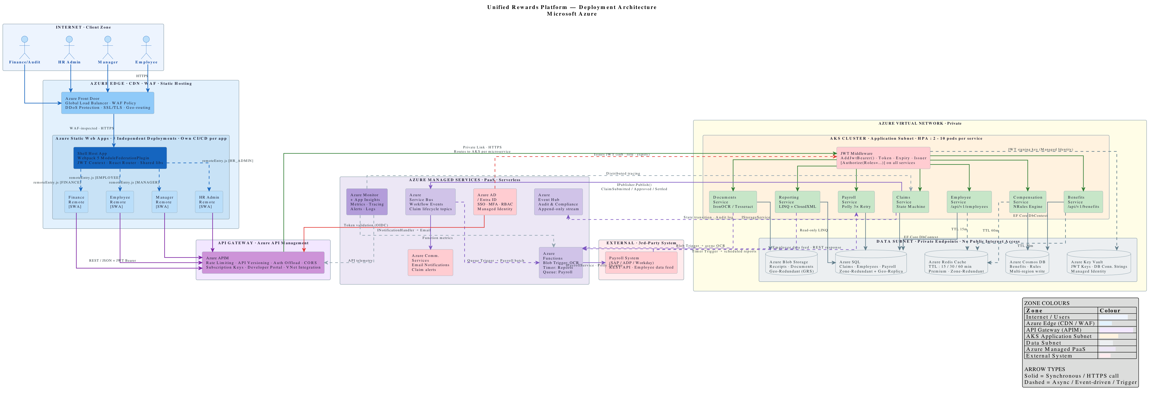
Figure: Azure Regional Deployment Layout — Multi-Region Topology

6.2 COMPONENT PHYSICAL DETAILS
The following section provides physical connectivity and specifications for all major Azure infrastructure components:
Component | Physical Location | VM SKU / Service Tier | Network Connectivity | Notes
AKS System Node Pool | East US 2 — AZ 1,2,3 | Standard_D2s_v3 (2 vCPU / 8 GB) | Azure CNI; NSG: allow kubectl from DevOps IPs only | 3 nodes, 1 per AZ; kube-system + monitoring workloads
AKS User Node Pool (Prod) | East US 2 — AZ 1,2,3 | Standard_D4s_v3 (4 vCPU / 16 GB) | Azure CNI; Application Subnet 10.0.2.0/24 | Min 5 nodes; HPA scales to 10; all 7 microservices + Functions
Azure SQL Primary | East US 2 — Zone-redundant | General Purpose GP_Gen5_4 (4 vCores) | Private Endpoint 10.0.4.5; TLS 1.3 only | TDE enabled; 256 GB storage; auto-grow; PITR 35 days
Azure SQL Secondary (DR) | West US 2 | General Purpose GP_Gen5_4 (4 vCores) | Private Endpoint 10.1.4.5 | Read-only replica; auto-failover group; lag < 5 min
Azure Cosmos DB | East US 2 + West US 2 | Serverless / Auto-scale | Private Endpoint EUS2: 10.0.4.6; WUS2: 10.1.4.6 | Multi-region write; 2 containers; AES-256 encrypted
Azure Redis Cache P1 | East US 2 — Zone-redundant | Premium P1 (6 GB, 1 shard) | Private Endpoint 10.0.4.7; TLS 6380 only | No disk persistence; eviction: allkeys-lru; maxmemory-policy set
Azure Blob Storage | East US 2 + paired West US 2 | StorageV2 GRS | Private Endpoint 10.0.4.8; HTTPS 443 only | 3 containers: documents/, payslips/, reports/; Soft-delete 14d
Azure Service Bus | East US 2 — Zone-redundant | Premium 1 Messaging Unit | Private Endpoint 10.0.4.10; AMQP/TLS 5671 | 4 topics; 10 MB message size; Geo-DR alias configured

Note: All physical servers (AKS nodes) are ephemeral by design — no stateful data stored on node local disk. All state lives in Azure-managed data services listed above. Node OS disk is used for container layers only.

7.0 DETAILED DESIGN – SYSTEM INTEGRATION MODEL

7.1 SYSTEM INTEGRATION DETAILS
This section provides detailed specifications for all integration points of the Unified Rewards Platform including database configuration, backup requirements, monitoring, logging, port matrix, service accounts, and capacity planning.

7.1.1 DATABASE
The platform uses two database technologies. Detailed configuration:
Property | Azure SQL Database (Relational) | Azure Cosmos DB (NoSQL)
Service Tier | General Purpose GP_Gen5_4 (Prod) / GP_Gen5_2 (UAT) | Serverless / Auto-scale (400–4000 RU/s)
Collation / API | SQL_Latin1_General_CP1_CI_AS | Core (SQL) API
Authentication | Azure AD MSI (Workload Identity) — no SQL auth | Azure AD MSI — no connection string keys
Encryption at Rest | TDE (AES-256) — Microsoft-managed keys | Server-side encryption (AES-256)
Encryption in Transit | TLS 1.3 (port 1433) | HTTPS/TLS 1.3 (port 443)
Connection | Private Endpoint 10.0.4.5 — no public access | Private Endpoint 10.0.4.6 — no public access
High Availability | Zone-redundant (3 AZ replicas) | Multi-region write (EUS2 + WUS2)
Backup | PITR: 35 days; LTR: 12 weeks / 12 months | Continuous backup: 30-day restore window
Read replicas | 1 readable secondary in West US 2 (DR) | All regions are read/write in multi-region config
Max connections per service | 150 connections per EF Core service pool | HTTP-based SDK — no connection pool limit
Databases / Containers | 1 database: urp_db  Tables by domain: dbo.Users, dbo.Employees, dbo.Claims, dbo.ClaimLineItems, dbo.ClaimWorkflows, dbo.ClaimStatusHistories, dbo.Documents, dbo.Receipts, dbo.OCRResults, dbo.PayrollRecords, dbo.Settlements, dbo.PaySlips, dbo.Reports, dbo.AuditEntries | 1 account: urp-cosmos  2 containers:  · BenefitPlans (partitionKey: /planType)  · CompensationRules (partitionKey: /applicableGrade)
EF Core Config | Code-first migrations; per-service DbContext; UseAzureSql(); connection from Key Vault | Cosmos DB SDK directly (no EF Core); per-container repository pattern
Index Strategy | Primary keys: UNIQUEIDENTIFIER (NEWSEQUENTIALID()); FK indexes on employee_id, claim_id, payroll_id; Filtered index on Claims.status for active claims query | Auto-indexed all properties; custom composite index on (grade, validFrom) for CompensationRules

7.1.2 BACKUP REQUIREMENTS
Service | Backup Type | Schedule | Retention Period | Restore Target | Responsible
Azure SQL Database | Automated PITR (full + diff + log) | Full: Sunday 02:00 UTC; Diff: every 12h; Log: every 5–10 min | PITR: 35 days; LTR: 12 weeks (weekly), 12 months (monthly) | Restore to same or new server in same region (or DR region) | Azure Platform (automatic)
Azure Cosmos DB | Continuous backup (built-in) | Real-time — no schedule | 30 days rolling window | Restore to new Cosmos DB account; re-point service | Azure Platform (self-service restore)
Azure Blob Storage | GRS replication + soft delete | Continuous geo-replication; soft delete trigger on deletion | GRS: permanent; Soft delete: 14 days | Undelete via Azure CLI; RA-GRS read access during outage | Azure Platform (automatic)
Azure Key Vault | Automatic paired-region replication | Continuous (Azure-managed) | Permanent (all versions retained) | Auto-available in DR region; no manual restore needed | Azure Platform (automatic)
AKS Cluster Manifests | GitOps — GitHub repository | Every infrastructure commit | Git history unlimited | kubectl apply -f from GitHub repository | DevOps team
Docker Images (ACR) | Azure Container Registry — built on each CI/CD push | Per commit to main branch | 30 most recent tags per image repository | Re-pull from ACR; redeploy via kubectl | GitHub Actions (automated)
Azure App Configuration / ConfigMaps | Kubernetes ConfigMaps in GitOps repository | Every config change committed | Git history unlimited | Re-apply from Git; no data risk (non-sensitive) | DevOps team

7.1.3 ANTI-VIRUS
The Unified Rewards Platform uses Azure Defender for Cloud (Microsoft Defender) as the primary threat detection and anti-malware solution. No traditional AV agent is deployed on AKS nodes (Kubernetes containers are ephemeral and immutable by design).
The following security controls provide anti-malware equivalent protection:
Security Control | Technology | Scope | Configuration
Container Image Scanning | Microsoft Defender for Containers | All Docker images in Azure Container Registry (ACR) | Scan on every push to ACR; block deployment if HIGH/CRITICAL CVE detected
Runtime Threat Detection | Microsoft Defender for Containers (K8s layer) | AKS cluster — all running pods | Alerts on: privilege escalation, suspicious process, crypto mining, port scanning
Azure SQL Threat Detection | Microsoft Defender for SQL | Azure SQL Database (urp-prod-sql-eus2) | Alerts on: SQL injection, anomalous access, brute force; Email alert to security team
Blob Storage Malware Scanning | Microsoft Defender for Storage | documents/ container (receipt uploads) | Scan uploaded files on Blob Trigger event; quarantine malware detections before OCR processing
Network Threat Detection | Azure Firewall / NSG Flow Logs + Defender for Cloud | All VNet traffic across Application and Data subnets | Alert on: unexpected outbound connections, DDoS attempts, lateral movement
File Exclusions (AKS Nodes) | N/A (container-based — no persistent files on nodes) | N/A | Containers are read-only filesystem; /tmp is ephemeral; no persistent files to exclude

7.1.4 MONITORING
Azure Monitor + Application Insights provides full-stack observability. The following table lists key monitoring services and parameters:
Performance Parameter | Description | Alert Trigger Threshold | Alert Action
AKS Pod CPU Utilization | Average CPU usage across all pods per service | > 70% for > 5 min | Scale out via HPA (automatic); PagerDuty alert if > 90%
AKS Pod Memory Utilization | Average memory usage across all pods per service | > 80% for > 5 min | PagerDuty alert; pod OOM kills trigger incident
HTTP Request Duration (P95) | 95th percentile API response time across all APIM routes | > 500ms for synchronous APIs; > 2s for reports | Azure Monitor alert → PagerDuty high priority
HTTP 5xx Error Rate | Percentage of API responses with 5xx status code | > 1% over 5-minute window | PagerDuty critical alert; auto-rollback trigger in GitHub Actions
Azure SQL DTU / CPU | Database CPU and DTU consumption | > 80% DTU for > 10 min | Alert to DBA team; consider scale-up to GP_Gen5_8
Azure SQL Connection Pool | Active connections approaching pool limit | > 120 connections per service (limit: 150) | Alert to DevOps; investigate connection leak
Cosmos DB RU/s Consumption | Request Units consumed vs provisioned (400–4000 RU/s auto-scale) | > 80% of max 4000 RU/s | Alert to DevOps; increase max RU/s if sustained
Redis Cache Hit Ratio | Percentage of cache reads served from cache (not DB) | < 80% hit ratio over 30 min | Investigation alert: cache invalidation issue or cold start
Service Bus Message Backlog | Unprocessed messages in any topic subscription | > 50 messages for > 10 min | Alert to DevOps; check subscriber service health
Dead Letter Queue (DLQ) Depth | Failed messages in DLQ (Payroll Service → External Payroll) | > 0 messages | Critical alert — manual intervention required for payroll push failure
Event Hub Consumer Lag | Lag between Event Hub publish and Reporting Service consumption | > 1000 events unprocessed for > 5 min | Alert to DevOps; check Reporting Service health
Azure Key Vault Throttling | Key Vault operation latency or throttling events | > 5 throttled requests in 1 min | Alert to DevOps; review MSI request patterns
OCR Processing Duration | Time for Azure Function OCR Blob Trigger to complete | > 30 seconds per document | Alert to DevOps; check Tesseract.Net performance / file size
PaySlip Generation Failures | Failed PaySlip PDF generation (ClosedXML) per payroll cycle | > 0 failures | Critical alert to Payroll team; PaySlip regeneration required
Application Insights Exceptions | Unhandled exceptions logged by Serilog across all services | > 10 exceptions/min per service | Alert to respective service development team

7.1.5 LOGGING
All 7 microservices use Serilog v3.x for structured logging. Log pipeline is environment-specific:
Environment | Log Sink | Log Level | Retention | Format
Local Development | Console (Serilog Console Sink) | Debug+ | N/A (session only) | JSON structured text
UAT | Azure Application Insights (via Serilog AI Sink) | Information+ | 90 days (App Insights) | JSON — enriched with CorrelationId, ServiceName, Environment
Production | Azure Event Hub (primary audit sink) + Azure Application Insights (telemetry) | Information+ (Event Hub); Warning+ (App Insights) | Event Hub: 30 days; App Insights: 90 days | JSON structured — AuditEvent schema for Event Hub; ITelemetry for App Insights

Logging enrichment properties added to every log entry:
- x-correlation-id: UUID propagated from HTTP request header across all service calls (set by APIM on inbound if absent).
- ServiceName: "employee-service", "claims-service", etc. — set in appsettings.json per deployment.
- Environment: "Production", "UAT" — from ASPNETCORE_ENVIRONMENT.
- UserId: extracted from JWT sub claim by Serilog enricher middleware.
- MachineName: AKS pod name (from Kubernetes downward API env var).
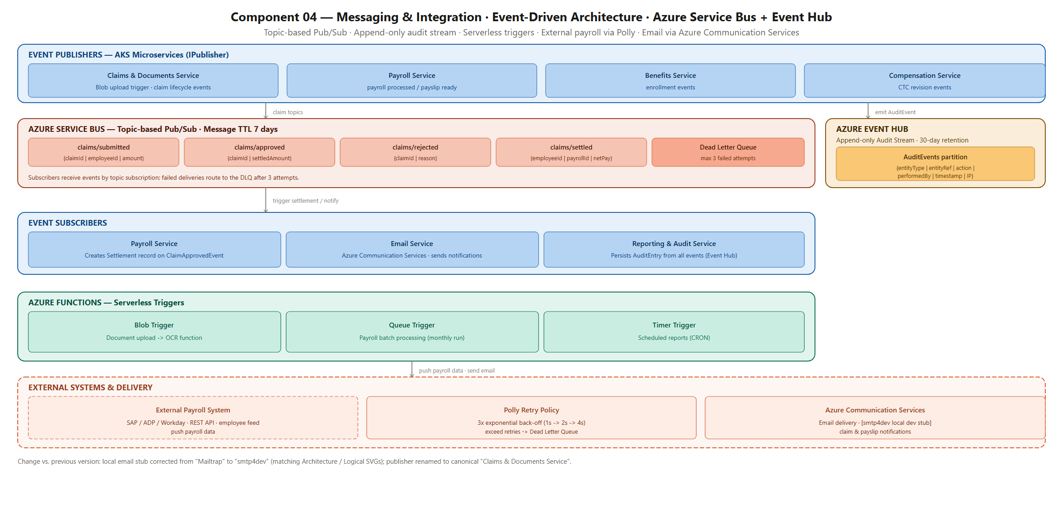
Figure: Logging Architecture — Serilog Pipeline — Event Hub, Service Bus & App Insights

7.1.6 SOURCE AND DESTINATION PORTS
The table below lists all source-to-destination port definitions for the Unified Rewards Platform:
Source | Destination | Port / Protocol | Direction | Configurable | Note
End User Browser | Azure Front Door | 443 / HTTPS | Inbound | No | WAF inspection applied; HTTP 80 redirected to 443
Azure Front Door | Azure Static Web Apps | 443 / HTTPS | Outbound | No | CDN edge to origin; TLS only
MFE Portal (Browser) | Azure APIM | 443 / HTTPS | Outbound | No | Bearer JWT required; CORS enforced
Azure APIM | AKS Services (internal) | 443 / HTTPS | Outbound | Yes | Private Link; APIM → AKS via internal IP 10.0.2.x
AKS Services | Azure SQL Database | 1433 / TDS+TLS | Outbound | No | Private Endpoint 10.0.4.5; TLS enforced; MSI auth
AKS Services | Azure Cosmos DB | 443 / HTTPS | Outbound | No | Private Endpoint 10.0.4.6; MSI auth; SDK HTTPS
AKS Services | Azure Redis Cache | 6380 / TLS | Outbound | No | Private Endpoint 10.0.4.7; TLS only (non-TLS port 6379 disabled)
AKS Services | Azure Blob Storage | 443 / HTTPS | Outbound | No | Private Endpoint 10.0.4.8; MSI auth; SDK HTTPS
AKS Services | Azure Service Bus | 5671 / AMQP+TLS | Outbound | No | Private Endpoint 10.0.4.10; MSI auth; AMQP over TLS
AKS Services | Azure Event Hub | 5671 / AMQP+TLS | Outbound | No | Private Endpoint 10.0.4.11; MSI auth; append-only
AKS Services | Azure Key Vault | 443 / HTTPS | Outbound | No | Private Endpoint 10.0.4.9; MSI auth; read-only (Get)
Azure Functions | Azure Blob Storage | 443 / HTTPS | Inbound trigger | No | Blob Trigger binding; same Private Endpoint 10.0.4.8
Azure Functions | Azure SQL Database | 1433 / TDS+TLS | Outbound | No | Timer/Queue trigger functions write to SQL; MSI auth
Payroll Service | External Payroll (SAP/ADP) | 443 / HTTPS | Outbound | Yes | Via AKS NAT Gateway public IP; API Key auth; Polly retry
Azure AD / Entra ID | Azure APIM (JWKS endpoint) | 443 / HTTPS | Inbound | No | APIM fetches JWKS for JWT validation; Internet egress allowed
GitHub Actions (CI/CD) | Azure Container Registry | 443 / HTTPS | Outbound | No | Push Docker images; OIDC federation (no stored credentials)
GitHub Actions (CI/CD) | AKS (kubectl) | 443 / HTTPS | Outbound | No | kubectl apply via AKS API server; OIDC auth; NSG: allow GitHub IPs
Azure Monitor Agent | Log Analytics Workspace | 443 / HTTPS | Outbound | No | AKS node telemetry; infrastructure logs
DevOps Engineer (VPN) | AKS API Server | 443 / HTTPS | Inbound | Yes | Authorized IP range restricted to Cognizant VPN egress IPs only

7.1.7 SERVICE ACCOUNTS
The Unified Rewards Platform uses Azure Managed Identity (Workload Identity) for all service-to-Azure-service authentication. No shared service account passwords are used.
Account Name / Identity | Account Type | Used For | Permissions
urp-employee-svc-identity | AKS Workload Identity (MSI) | User Management Service → Azure SQL (urp_db), Key Vault secret reads, Redis Cache | SQL: db_datareader + db_datawriter on dbo.Users + dbo.Employees; Key Vault: Secret Get; Redis: READ+WRITE
urp-benefits-svc-identity | AKS Workload Identity (MSI) | Benefits Service → Azure Cosmos DB (BenefitPlans container), Key Vault, Redis | Cosmos DB: Contributor on BenefitPlans + BenefitEnrollments; Key Vault: Secret Get; Redis: READ+WRITE
urp-compensation-svc-identity | AKS Workload Identity (MSI) | Compensation Service → Azure Cosmos DB (CompensationRules), Key Vault, Redis | Cosmos DB: Contributor on CompensationRules container; Key Vault: Secret Get (Tesseract.Net key); Redis: READ+WRITE
urp-claims-svc-identity | AKS Workload Identity (MSI) | Claims & Documents Service → Azure SQL (Claims tables), Service Bus (publish), Event Hub (audit), Key Vault | SQL: db_datareader + db_datawriter on Claims schema; Service Bus: Send on 4 topics; Event Hub: Send; Key Vault: Secret Get
urp-documents-svc-identity | AKS Workload Identity (MSI) | Document & OCR component → Azure Blob Storage (documents/ container), Azure SQL (Documents+Receipts+OCRResults), Key Vault | Blob: Storage Blob Data Contributor on documents/ container; SQL: db_datareader + db_datawriter; Key Vault: Secret Get
urp-payroll-svc-identity | AKS Workload Identity (MSI) | Payroll Service → Azure SQL (Payroll tables), Blob (payslips/), Service Bus (subscribe), Event Hub, Key Vault | SQL: db_datareader + db_datawriter on Payroll schema; Blob: Storage Blob Data Contributor on payslips/; Service Bus: Listen on claims/approved; Key Vault: Secret Get (external payroll API key)
urp-reporting-svc-identity | AKS Workload Identity (MSI) | Reporting Service → Azure SQL (read-only: all tables), Blob (reports/), Event Hub (consume), Key Vault | SQL: db_datareader on all tables (read-only — no writes to transactional tables); Blob: Storage Blob Data Contributor on reports/; Event Hub: Listen (AuditEntry ingestion); Key Vault: Secret Get
urp-functions-identity | Azure Functions Managed Identity | Azure Functions App → Azure Blob (Blob Trigger), Azure SQL (Timer/Queue write), Key Vault | Blob: Storage Blob Data Reader on documents/ (Blob Trigger); SQL: db_datawriter (OCRResults, Reports); Key Vault: Secret Get
urp-github-actions-oidc | GitHub Actions OIDC Federation (no secret) | GitHub Actions CI/CD → Azure Container Registry (image push), AKS (kubectl deploy) | ACR: AcrPush role; AKS: Azure Kubernetes Service Contributor role (namespace-scoped to urp-prod / urp-uat)
urp-monitoring-identity | Azure Monitor Managed Identity | Azure Monitor Agent on AKS nodes → Log Analytics Workspace | Log Analytics: Monitoring Metrics Publisher; Reader on all urp-prod-rg resources

7.1.8 SYSTEM ADMINISTRATION
Role Based Account assignments for platform administration:
Role Name | Permissions | Azure AD / Entra Group | Purpose
Platform Administrator | Owner on urp-prod-rg; AKS Cluster Admin; Key Vault Administrator | grp-urp-platform-admins | Full platform administration; break-glass access; restricted to 2–3 persons with PIM (Privileged Identity Management)
DevOps Engineer | Contributor on urp-prod-rg (excluding Key Vault); AKS Cluster User; ACR Push/Pull | grp-urp-devops | CI/CD pipeline management; AKS deployment; image builds. No access to Key Vault secrets.
Developer (Backend) | Reader on urp-uat-rg; AKS Cluster User (uat namespace only); Azure SQL (uat db — db_owner) | grp-urp-backend-devs | UAT environment access for debugging; read-only on Production; no access to Production data
Developer (Frontend) | Reader on urp-uat-rg; Azure Static Web Apps Contributor (uat) | grp-urp-frontend-devs | UAT portal deployment; read-only on Production resources
DBA / Data Engineer | SQL Server Contributor on urp-prod-sql-eus2; db_owner on urp_db (prod) | grp-urp-dba | Schema changes; index optimization; PITR restore execution; read-only Cosmos DB access
Security Administrator | Security Reader + Microsoft Defender for Cloud alerts; Key Vault Administrator | grp-urp-security-admins | Security monitoring; WAF rule management; Key Vault key rotation; Defender for Cloud alert triage
L1/L2 Support | Reader on all urp-prod-rg resources; Application Insights Reader; Log Analytics Reader | grp-urp-support | Read-only monitoring access; log viewing for incident investigation; no configuration changes

7.1.9 CAPACITY AND SCALABILITY MANAGEMENT
Current deployment capacity and available scaling options:
Component | Current Capacity (Production) | Utilization Target | Scale-Out Option | Scale Trigger
AKS User Nodes | 5 nodes × Standard_D4s_v3 (4 vCPU / 16 GB each) = 20 vCPU / 80 GB total | 60–70% CPU average | Add nodes to user node pool (max 20); Upgrade to Standard_D8s_v3 (8 vCPU) | Cluster Autoscaler: node CPU > 80% for > 10 min
AKS Pods (per service) | 2 min → 10 max per service (7 services × 2 min = 14 pods baseline) | 70% CPU per pod | HPA automatically scales within 2–10 range; increase max in HPA manifest | HPA: CPU > 70% targetAverageUtilization
Azure SQL Database | GP_Gen5_4 (4 vCores, 20.4 GB RAM, 256 GB storage) | 50–60% DTU | Scale to GP_Gen5_8 (8 vCores) via Azure Portal — zero downtime; storage auto-grows to 4 TB | DTU > 80% for > 30 min; manual trigger
Azure Cosmos DB | 400–4000 RU/s auto-scale per container (2 containers) | 40–60% of max RU/s | Increase max RU/s to 10,000 RU/s via SDK or Portal; no downtime | Azure Monitor: RU/s > 80% of max auto-scale ceiling
Azure Redis Cache | Premium P1: 6 GB RAM / 1 shard | < 50% memory | Scale to P2 (13 GB) or P3 (26 GB); cluster sharding up to 10 shards | Memory usage > 80% for > 15 min; manual trigger
Azure Service Bus | Premium 1 MU (1 Messaging Unit = ~1000 msg/sec) | < 30% throughput | Add Messaging Units (up to 16 MU) via Portal — no downtime | Sustained > 80% MU throughput; manual trigger
Azure Blob Storage | StorageV2 GRS (up to 5 PB per account) | < 1% (well within limits) | Add more storage accounts if > 4.75 PB; unlikely in foreseeable future | N/A — effectively unlimited
APIM Throughput | Premium tier: 4000 req/sec (theoretical); rate limit: 100 req/min per subscription | < 20% of theoretical throughput | Scale Premium units (add Scale units via Portal); increase rate limits in policy | HTTP 429 error rate > 5%; manual review
Azure Functions | Consumption plan — scales 0 to 200 instances automatically | N/A (serverless) | Upgrade to Premium plan for VNet integration and pre-warmed instances if cold-start > 1 sec | Cold-start latency > 1 sec on Blob Trigger OCR function

8.0 DOCUMENTS REFERENCED
Document Name | Brief Description | Document Location
Cognizant-UnifiedRewardsPlatform-HLD v1.0 | High Level Design and Architecture Document covering all 11 architectural views | docs/HLD_doc/Cognizant-UnifiedRewardsPlatform-HLD v1.0.docx
Cognizant-UnifiedRewardsPlatform-API Specification v1.0 | REST API contracts for all 7 microservices with request/response schemas | docs/Cognizant-UnifiedRewardsPlatform-API Specification v1.0.docx
Requirement Analysis & Clarification Document v1.1 | Platform functional and non-functional requirements; 26 clarification items | docs/Requirement_Analysis_Clarification_Document.md
System Architecture Diagram v2 | Layered logical architecture with all tiers and cross-cutting concerns | docs/Diagrams/Architecture_Diagram_1.pdf
Deployment Architecture Diagram | Azure VNet topology with private endpoints, AZ layout, and region distribution | docs/Diagrams/Deployment_Architecture_Diagram.pdf
ER Diagrams — Master + Domain Level | Entity-relationship diagrams for all 7 domains with table definitions | docs/Diagrams/ER_Diagrams/ (er_00_master.png through er_07_reporting_audit.png)
Sequence Diagrams (6 flows) | End-to-end sequence diagrams for Claim Submission, Enrollment, Compensation, Payroll, Promotions, Reporting | docs/Diagrams/Sequence_Diagrams/ (seq_01_claim_submission_approval.png through seq_06_reporting_audit.png)
Domain Class Diagrams (7 domains) | Class-level domain models for all 7 bounded contexts | docs/Diagrams/Class_Diagrams/ (01_user_management.png through 07_reporting_audit.png)
Component Diagrams (6 views) | Component diagrams covering System Overview, Frontend, Backend, Data, Messaging, Security | docs/Diagrams/Component_Diagrams/ (comp_00_SystemOverview.png through comp_05_SecurityIdentity.png)
Cognizant Corporate Security Policy (QSIS-APPARCDES) | Application architecture and design security standard | https://corporatesecurity.cognizant.com/Policies/Corporate_Security_Policies/Standards/QSIS-APPARCDES.pdf
Microsoft Azure Well-Architected Framework | Azure architecture best practices: Reliability, Security, Cost, Performance, Operations | https://learn.microsoft.com/azure/architecture/framework/
OWASP Top 10 — 2021 | Web application security risk framework — applied to APIM WAF policy | https://owasp.org/www-project-top-ten/

9.0 LIST OF TABLES
Table 1. Document Revision History
Table 2. Cognizant Review and Approvals
Table 3. Trademarks
Table 4. Abbreviations, Terms and Definitions
Table 5. Functional Business and Technical Requirements
Table 6. Non-Functional Business Requirements
Table 7. Architectural Design Decisions
Table 8. Logical Layer Technology Stack
Table 9. Design Components
Table 10. Server Roles
Table 11. Server Sizing Details
Table 12. Appliance / Service Details
Table 13. Software Prerequisites
Table 14. External References (per section)
Table 15. AKS and Azure Service HA Configuration
Table 16. DR Strategy — RTO/RPO Targets
Table 17. Backup Requirements
Table 18. Namespace and Numbering Schemes
Table 19. Component Physical Details
Table 20. Azure SQL vs Cosmos DB Configuration
Table 21. Anti-Virus / Security Controls
Table 22. Monitoring Services and Parameters
Table 23. Logging Configuration by Environment
Table 24. Source and Destination Ports
Table 25. Service Accounts / Managed Identities
Table 26. Role-Based Accounts
Table 27. Capacity and Scalability Management
Table 28. Reference Documents

10.0 LIST OF FIGURES
Figure 1. Solution Architecture Overview
Figure 2. Detailed Logical Architecture (Layer Diagram)
Figure 3. Azure Regional Deployment Layout (Physical)
Figure 4. Logging Architecture — Serilog Pipeline

11.0 CHANGE LOG
Version Number | Changes Made
V1.0.0 | Initial baseline created on 23-May-2026 by Senior Solution Architect. Full LLD covering all 7 microservices, 4 MFE portals, Azure infrastructure, HA/DR strategy, monitoring, logging, port matrix, service accounts, capacity planning, and backup requirements for the Unified Rewards Platform.

Change Details
Section No. | Changed By | Effective Date | Changes Effected
All sections | Senior Solution Architect | 23-May-2026 | V1.0.0 — Initial baseline. All template sections authored: Trademarks, Abbreviations, Design Objectives, In/Out-Scope, Functional Requirements (FR-01–FR-13), Use Case Diagrams (8 diagrams), Non-Functional Requirements (NFR-01–NFR-08), Architectural Design Decisions (AD-01–AD-10), Solution Architecture, Logical Design, Design Components (24 items), Server Roles, Sizing, Prerequisites, HA/DR strategy (5.1–5.2.4), Namespace Schemes, Physical Details, Database, Backup, Anti-Virus, Monitoring, Logging, Port Matrix, Service Accounts, System Administration, Capacity & Scalability for the Unified Rewards Platform.

